D. Divide and Sum
time limit per test
2 seconds
memory limit per test
512 megabytes
input
standard input
output
standard output
You are given an array aa of length 2n2n. Consider a partition of array aa into two subsequences pp and qq of length nn each (each element of array aa should be in exactly one subsequence: either in pp or in qq).
Let's sort pp in non-decreasing order, and qq in non-increasing order, we can denote the sorted versions by xx and yy, respectively. Then the cost of a partition is defined as f(p,q)=∑ni=1|xi−yi|f(p,q)=∑i=1n|xi−yi|.
Find the sum of f(p,q)f(p,q) over all correct partitions of array aa. Since the answer might be too big, print its remainder modulo 998244353998244353.
Input
The first line contains a single integer nn (1≤n≤1500001≤n≤150000).
The second line contains 2n2n integers a1,a2,…,a2na1,a2,…,a2n (1≤ai≤1091≤ai≤109) — elements of array aa.
Output
Print one integer — the answer to the problem, modulo 998244353998244353.
Examples
input
Copy
1
1 4
output
Copy
6
input
Copy
2
2 1 2 1
output
Copy
12
input
Copy
3
2 2 2 2 2 2
output
Copy
0
input
Copy
5
13 8 35 94 9284 34 54 69 123 846
output
Copy
2588544
Note
Two partitions of an array are considered different if the sets of indices of elements included in the subsequence pp are different.
In the first example, there are two correct partitions of the array aa:
- p=[1]p=[1], q=[4]q=[4], then x=[1]x=[1], y=[4]y=[4], f(p,q)=|1−4|=3f(p,q)=|1−4|=3;
- p=[4]p=[4], q=[1]q=[1], then x=[4]x=[4], y=[1]y=[1], f(p,q)=|4−1|=3f(p,q)=|4−1|=3.
In the second example, there are six valid partitions of the array aa:
- p=[2,1]p=[2,1], q=[2,1]q=[2,1] (elements with indices 11 and 22 in the original array are selected in the subsequence pp);
- p=[2,2]p=[2,2], q=[1,1]q=[1,1];
- p=[2,1]p=[2,1], q=[1,2]q=[1,2] (elements with indices 11 and 44 are selected in the subsequence pp);
- p=[1,2]p=[1,2], q=[2,1]q=[2,1];
- p=[1,1]p=[1,1], q=[2,2]q=[2,2];
- p=[2,1]p=[2,1], q=[2,1]q=[2,1] (elements with indices 33 and 44 are selected in the subsequence pp).

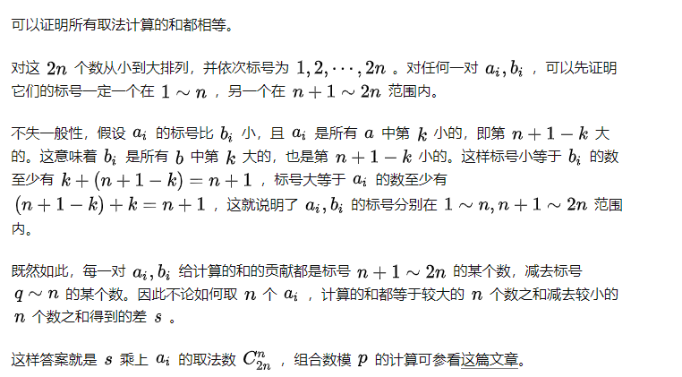
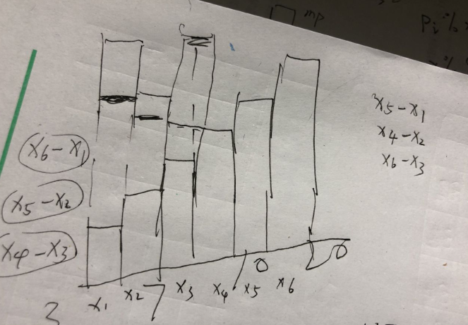
关于大的减小的不变的一点小小的证明

#include<bits/stdc++.h>
#define ll long long
using namespace std;
const ll mod=998244353;
ll inv[300009];
ll C(ll m,ll nn)
{
inv[1]=1;
for(int i=2;i<=300005;i++) inv[i]=((ll)(mod-mod/i)*(ll)inv[mod%i])%mod;
ll zhuhe=1;
for(int i=1;i<=nn;i++) zhuhe=(zhuhe*(ll)(m-i+1)%mod*inv[i])%mod;
return zhuhe;
}
int a[300009];
int main()
{
int n;
scanf("%d",&n);
n=n+n;
for(int i=1;i<=n;i++) scanf("%d",&a[i]);
sort(a+1,a+1+n);
ll x=0;
for(int i=1;i<=n/2;i++)
{
x+=abs(a[i]-a[i+n/2]);
x=x%mod;
}
ll m=n/2; ll nn=n;
ll ans=x*(C(nn,m));
cout<<ans%mod;
return 0;
}

